**World Journal of Research and Review (WJRR)**

**Volume-13, Issue-1, July 2022 Pages 06-09**

A Study of Weather Forecasting in IOT Technology

**E Bhavani**

 

***Abstract*— Weather forecasting is the most important things in the today’s world. Basically weather forecasting are used to provide the information about weather and their climate changes that ―how the climate are change with time?‖ weather forecasting is the use of science and technology to predict the condition of weather for given area. It is one of the most difficult issues the world over. This paper introduced a classify approach for prediction o0f weather condition and shows how Naïve-Bayes and Chi square algorithm can be utilized for classification purpose. In this paper we are going to shows that how various algorithms and Sensor are worked in weather forecasting? This system is a web-application with effective graphical user interface.**

***Index Terms*— IOT, Naïve-Bayes, Arduino, LCD display, Temperature sensor, Humidity sensor, Wi-Fi module.**

# I. INTRODUCTION

Weather monitoring has received much attention now days. At that time, people want to stay updated about the latest weather conditions of any place like: - Industrial areas, Office’s and Visiting areas etc. Various types of weather station are placed at various places to provide information about weather. Here in this paper we present a weather forecasting that is very helpful weather information for various places. Weather forecasting is equipped with environmental sensors used for measurements at any particular place and reports them in real time on cloud. Forecasts depended on temperature, Outlook, Humidity and wind. In weather forecasting various sensor we used which provide constantly sense the weather parameter’s and keep’s on transmitting it to online web server over a Wi-Fi connection. Weather parameters are uploaded on the cloud and then provide the live reporting of weather information. Weather forecasting systems are established in smart cities for forecasting the weather.

1. Internet of Things (IoT)

Internet of thing may be defined as a group of physical devices or sensors which connected to a network and have unique identifiers. IoT allows objects to be sensed and controlled remotely across existing network infrastructure, creating opportunities for more direct integration between physical world and computer based system. It is a future technology which connects the entire world. In IOT sensor or things are connected to each other which transfer the data over a network cloud. As per the survey of technological expert’s 45-55 Billion thing will be connected in IoT technology by 2022. IoT technology offered wide ranges of

|  |
| --- |
|  |

connectivity of sensors with various protocol and various properties of applications for obtaining complete interaction.

# II. LITERATURE REVIEW

A literature review is necessary to know about the research area and what problem in that area has been solved and what need to be solved in future. A proper literature review provides solid background for a noble research work. According to the Anita M. Bhagat All the physical devices, things, object and sensor connected to create a new world technology. According to the yashaswi Rahut weather forecasting is a new kind of technology which is based on Iota where its main focus on climate and environmental changes.

Existing model is represented IoT based weather forecasting and reporting system where people can collect, process, analyze and present measured data on web. In IoT technology, server is used to manage the resources of the network. The information provided by the internet that is connected through various networks, which is available for people or users via smart phones and web browser.

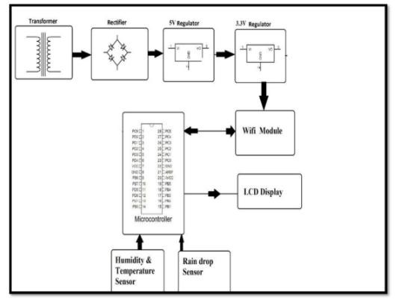

## Fig.1: Block Diagram of Weather forecasting

|  |
| --- |
| **A Study of Weather Forecasting in IOT Technology** |

**1. Naive Bayes Algorithm** - It based on byes theorem and it is a technique of classification. Naive Bayes Algorithm is a method or procedure which used to predict probability of different classes of a different attributes. It is used for text classification.

Bayes Theorem formula:-



P (A | B) = Posterior probability

P (A) = Prior class probability

P (B | A) = Likelihood

P (B) = Predictor Prior probability

# ***Applications:-***

* Text Classification
* Spam Filtering
* Real Time predication

1. **Arduino:** - Arduino is a tectonic device which is used as a Software and Hardware. Arduino provide open source platform. When we used Arduino as Software we can write programs using higher level language to perform a specific task of Iota technology, on the other side when we used Arduino as hardware, we can connect various sensors, actuator to the port of Arduino hardware.

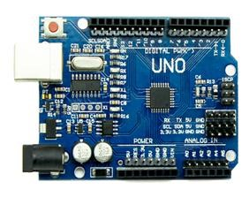

Fig. 2:

Ardu

ino

At that time different kind of Arduino devices are available

in the market which is following:

-

•

Arduino Uno (R3)

•

Arduino Nano.

•

Arduino Micro.

•

Arduino Due.

•

Lily Pad Arduino Board.

•

Arduino Bluetooth.

•

Arduino Decimal.

•

Red Board Arduino Boa

r0064

**4.**

**Wind Sensor:**

**-**

Wind Sensor is the type of sensor

which measuring the wind speed and direction.It is

also common weather station instrument.The wind

Sensor WM30 is a compact and economical wind

speed and direction sensor.The Rotating cup

anemometer at the top of the unit provides a linear

response to wind speed.

The vane, which attached to

the body of the unit,provides a fast response to wind

direction.

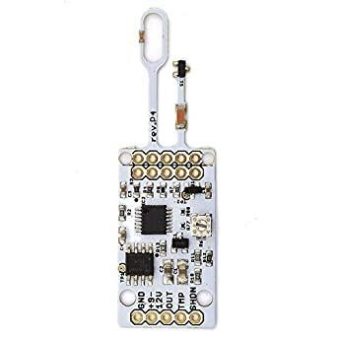

1. **Temperature sensor** - Temperature sensor is the part of the IoT things where the temperature sensor is a device which operates with the help of electricity. Temperature sensor is used to measure the temperature of a particular area or a place. For the weather forecasting project temperature sensor is most important sensor. Temperature sensor is made up of metal which measure the difference of temperature. Temperature sensor collects the input data of a particular area and converts into an electrical signals. Temperature sensor is also used to monitor the temperature of an area.

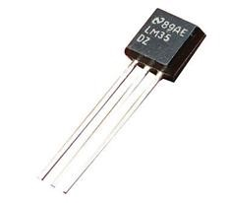

Fig. 3 : Temprature Sensor

## Fig. 4: Wind Module

|  |
| --- |
| **World Journal of Research and Review (WJRR)**  **ISSN: 2455-3956, Volume-13, Issue-1, July 2021 Pages 06-09** |

**5. Pressure Sensor:-** Pressure Sensor is the type of sensor which used to measure the pressure. Pressure is defined as the appiled force by liquid or gas on a surface and it is usually measured in units of force per unit of surface area.

So Pressure Sensor is an instrument consisting of pressure sensitive element to determine actual pressure.

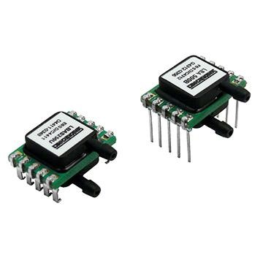

## Fig. 5: Pressure Module

**6. LCD Display**: - LCD stands for “Liquid Crystal Display “. LCD has a wide range of application and it is an electrical module. A 16 * 2 is a basic module which is used in any project of IoT. A 16 * 2 LCD means it can display 16 characters per line and there are 2 such lines. In LCD each character is displayed in 5x7 pixel matrix. LCD has two registers, namely, Command and Data. LCD module has preferred seven segments and other

LED’s. Because LCD are economically, It is easy to program, and no limitation of displaying any character’s.

We use LCD in weather forecasting project for displaying the content of the weather forecasting.

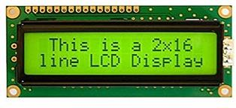

## Fig. 6: LCD Module

**7. Humidity sensor: --** In weather forecasting we can use Humidity sensor which is also known as DHT sensor. In weather forecasting project humidity sensor are used to identify the humidity of a particular area with respect to the temperature sensor. Basically DHT is a device which operates on electricity of low power consumption.

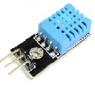

## Fig. 7: DHT sensor

**8. WI – Fi Module:** - Wi-Fi module is an integrated IC or CHIP. It is an electrical device. It use low power consumption. It has an external antenna to transmit the data over wi- fi network. It is used to provide the network access. It is real time clock module. In weather forecasting the WI – fi module is a most important part of the project because it is used to provide the network access and transmitted the weather forecasting content over the cloud.

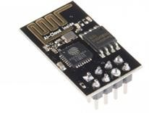

Fig. 8: Wi-Fi Module

## III. CONCLUSION

By keeping the weather station in the environment for monitoring enables self-protection to the environment. To implement weather forecasting need to use the sensor devices in the environment for collecting data and analysis. Then the collected data and analysis results will be available to the user through the Wi-Fi. The data will be helpful for future analysis. This model can be expanded to monitor the developing cities and industrial zone for pollution monitoring. To protect the public the public health from pollution, this model provides an efficient and low cost solution.

**A Study of Weather Forecasting in IOT Technology**

REFERENCES

1. International Journal of Advanced Research in Computer and Communication Engineering ISO 3297:2007 Certified Vol.5, Issue 9, September 2016.
2. International Journal of Engineering Trends and Technology (IJETT) – Volume 32 Number 2- February 2016.
3. International Journal of Engineering Science and Computer, May2017. [4] Sagar J.S.T.,M.S Balamurugan and J.A. Vivek, “A wireless framework for automotive monitoring systems,” in Indian Journal of Science and Technology, Vol 8[19], IPL0146, August 2015.
4. https://www.openhacks.com/uploadsproductors/rain_sensor_module.p

df

1. https://designinformaticslab.github.io/productdesign_tutorial/2017/01/ 24/soilmoisture_sensor.html.
2. http://www.hackster.io/techmirtz/using-16x2-lcd-with-ardunio-d8902

8.

1. https://www.arduino.cc/en/Guide/ArduinoUnoWiFi.
2. Written IH,Frank E.Machine Learning Tools and Techniques. Second edition.2005
3. Bregman J I, Mackenthum K.M. Environmental Impact Statement, Chelsea: MI Lewis Publication.2006.

1. A. Shahi, et al., "An effective fuzzy c-mean and type 2 fuzzy," Journal of Theoretical and applied Information Technology (JATIT), vol. 5, pp. 556-567, 2009.

1. R. Sallehuddin, et al., "Forecasting Time Series data using Hybrid Grey Relational Artificial Neural Network and Auto Regressive Integrated Moving Average," Journal of Applied Artificial Intelligence, vol. 23.

1. M. Tektaş, "Weather forecasting using ANFIS and ARIMA models. A case study for Istanbul," Environmental Research, Engineering and Management, vol. 51, pp. 5-10, 2010.

1. M. H. F. Zarandi, et al., "Type – II fuzzy possibilistic CMean clustering," presented at the International Fuzzy System Association/European Sociatey for Fuzzy Logic and Technology, Portugal, 2009.

1. D. Kalenatic, et al., "A Neuro-Evolutive Interval Type-2 TSK Fuzzy System for Volatile Weather Forecasting.," presented at the International Conference on Intelligent Computing, 2010.

1. N. Merh, V.P. Saxena and K.R. Pardasani, “A comparison between hybrid approaches of ANN and ARIMA for INDIAN stock trend forecasting,” BIJ, vol.3 no.2, July 2010, pp. 23-43.

1. A. I. Dounis, P. Tiropanis, D. Tseles, G. Nikolaou, and G. P. Syrcos,

“A Comparison of Grey Model and Fuzzy Predictive Model for Time Series,” International Journal of Information and Mathematical Sciences 2006

1. S. Chen, Y. Chang, C. Cheng and S. Huang, "Temperature Prediction Based on Fuzzy Clustering and Fuzzy Rules Interpolation Techniques,” SMC 2009. IEEE International Conference, pp.3444-3449.

1. K. Lalarukh, Z. J. Yasmin, “Time series models to simulate and forecast hourly averaged wind speed in Quetta, Pakistan,” Solar Energy 1997; vol. 61, no.1, pp.23-32.